

Foundations of Programming

Lab Assignment No. : 03

PROBLEM STATEMENT:
Write a program in C to generate multiplication tables for a given number.
OBJECTIVES:
- To understand the use of looping statements in C.
- To generate multiplication tables using loops.
- To improve program logic and execution flow understanding.

THEORY:
1 Syntax for for loop example program
for(int i = 1; i <= 10; i++)
{
printf("%d ", i);
}
2 Syntax for while loop example program
int i = 1;
while(i <= 10)
{
printf("%d ", i);
i++;
}
3 Syntax for do while loop example program
int i = 1;
do
{
printf("%d ", i);
i++;
}
while(i <= 10);
ALGORITHM:
1 Start
2 Declare variables num and i
3 Ask the user to enter a number
4 Read the number
5 Initialize i = 1
6 Repeat while i ≤ 10
7 Print num × i = result
8 Increment i by 1
9 Stop when i > 10
10 End

PLATFORM:
Linux
CODE:
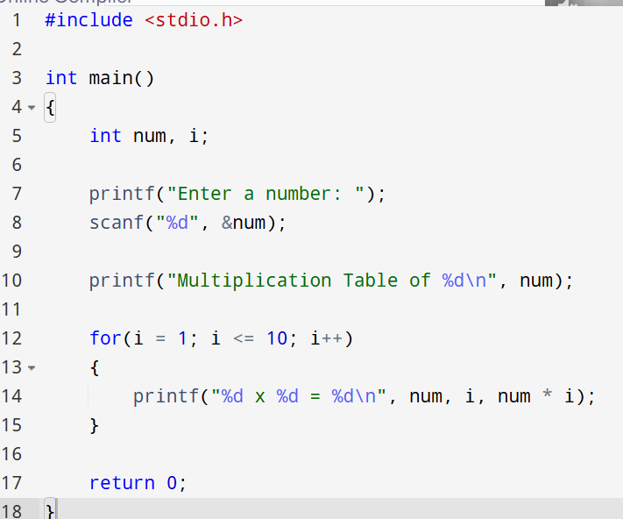

INPUT:

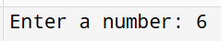
OUTPUT:
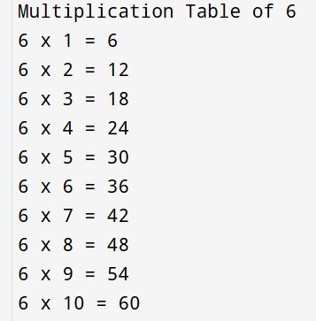

CONCLUSION:
Thus, the menu driven program in C successfully performs basic arithmetic operations using switch–case statements.

FAQs:
- Which loop is best suited for generating multiplication tables?
- What is the role of loop initialization?
- Difference between for loop, while loop and do while loop?
- Can a do–while loop be used to generate multiplication tables? Explain.
- Why is the do–while loop called an exit-controlled loop?
Flowchart
